**ML|LLM Interview**

**Shivnandan rai**

**Linear regression**

is a popular supervised machine learning algorithm used for predicting a continuous target variable (also called the dependent variable) based on one or more predictor variables (independent variables). The primary goal of linear regression is to find the best-fit linear relationship between the predictors and the target variable.

Here's how linear regression works, including the objective function and gradient descent:

* Objective Function (Cost Function): The objective in linear regression is to find the parameters (coefficients) of the linear model that minimize the difference between the predicted values and the actual values of the target variable. This is typically done using a cost function. The most common cost function for linear regression is the Mean Squared Error (MSE) or the Sum of Squared Residuals (SSR), which is defined as:  
  MSE = (1 / 2m) * Σ(yi - ŷi)^2  
  Where:
  + MSE: Mean Squared Error, the cost to be minimized.
  + m: The number of data points in the dataset.
  + yi: The actual value of the target variable for the ith data point.
  + ŷi: The predicted value of the target variable for the ith data point.
* Gradient Descent: Gradient Descent is an optimization algorithm used to minimize the cost function. It iteratively updates the model parameters to find the values that minimize the cost. For linear regression, the model parameters are the coefficients (weights) of the linear equation.  
  The gradient descent algorithm starts with some initial values for the coefficients and iteratively updates them. The update rule for linear regression is as follows:  
  θj = θj - α * (∂MSE/∂θj)  
  Where:
  + θj: The jth coefficient (weight) of the linear regression model.
  + α (alpha): The learning rate, a hyperparameter that controls the step size in the parameter space.
  + ∂MSE/∂θj: The partial derivative of the MSE with respect to θj, which represents the gradient of the cost function with respect to that parameter.

The algorithm continues to update the coefficients until convergence is reached, which occurs when the changes in the cost function become very small, or after a fixed number of iterations.

Here's a high-level overview of the steps in gradient descent for linear regression:

* Initialize the coefficients θj.
* Compute the predicted values ŷi using the current coefficients.
* Compute the gradient (∂MSE/∂θj) for each coefficient.
* Update each coefficient θj using the update rule.
* Repeat steps 2-4 until convergence is achieved or a predetermined number of iterations is reached.

The choice of the learning rate (α) is crucial in gradient descent, as it can affect the algorithm's convergence. If α is too small, the algorithm may converge slowly, and if it's too large, it may overshoot the minimum. Proper tuning of the learning rate is often necessary for effective gradient descent.

1. What is linear regression, and how does it work?

* Linear regression is a statistical method used to model the relationship between a dependent variable and one or more independent variables. It assumes a linear relationship between the variables and aims to find the best-fitting line (or hyperplane in multiple dimensions) to make predictions.

2. What are the assumptions of linear regression?

* Linear regression assumes linearity, independence of errors, homoscedasticity (constant variance of errors), and normally distributed errors.

3. Explain the difference between simple linear regression and multiple linear regression.

* Simple linear regression involves one independent variable, while multiple linear regression involves more than one independent variable.

4. What is the purpose of the coefficient of determination (R-squared) in linear regression?

* R-squared measures the proportion of the variance in the dependent variable that can be explained by the independent variables. It ranges from 0 to 1, where higher values indicate a better fit of the model to the data.

5. How do you interpret the coefficients in a linear regression model?

* The coefficients represent the change in the dependent variable for a one-unit change in the corresponding independent variable, while holding all other variables constant.

6. What is the difference between correlation and regression?

* Correlation measures the strength and direction of a linear relationship between two variables, but it doesn't imply causation. Regression, on the other hand, models the effect of one or more independent variables on a dependent variable.

7. What are the methods to assess the goodness of fit of a linear regression model?

* Some common methods include R-squared, adjusted R-squared, F-statistic, and p-values for the coefficients.

8. What is the purpose of the F-statistic in linear regression?

* The F-statistic is used to test the overall significance of the regression model. It compares the fit of the model with independent variables to a null model with no independent variables.

9. What are the potential problems in linear regression analysis, and how can you address them?

* Common problems include multicollinearity, heteroscedasticity, and outliers. Solutions may involve removing or transforming variables, using robust standard errors, or applying regularization techniques.

10. What are some regularization techniques used in linear regression, and when are they applicable?

* Regularization techniques like Ridge and Lasso regression are used to prevent overfitting by adding a penalty term to the loss function. Ridge adds L2 regularization, while Lasso adds L1 regularization. They are applicable when dealing with high-dimensional data and multicollinearity.

11. Can you explain the concept of bias-variance trade-off in the context of linear regression?

* The bias-variance trade-off refers to the trade-off between a model's ability to fit the data well (low bias) and its ability to generalize to new data (low variance). Increasing model complexity typically reduces bias but increases variance, and vice versa.

**What is L1 and L2 regression?**

* L1 Regularization (Lasso): L1 regularization adds the absolute values of the coefficients as a penalty term to the linear regression's loss function. It encourages some of the coefficients to be exactly zero, effectively performing feature selection.
* L2 Regularization (Ridge): L2 regularization adds the squared values of the coefficients as a penalty term to the linear regression's loss function. It penalizes large coefficient values and encourages all coefficients to be small but non-zero.

2. What's the main purpose of L1 and L2 regularization in linear regression?

* Answer: The main purpose of L1 and L2 regularization in linear regression is to prevent overfitting. They achieve this by adding a penalty term to the loss function that discourages the model from fitting the data too closely, which can result in complex and unstable models. L1 encourages sparsity and feature selection, while L2 encourages smaller, more evenly balanced coefficients.

3. How do L1 and L2 regularization affect the model's coefficients?

* Answer: L1 regularization tends to drive some of the coefficients to exactly zero, effectively performing feature selection by eliminating certain features from the model. L2 regularization, on the other hand, shrinks the coefficients toward zero but rarely makes them exactly zero. It encourages all features to contribute to the prediction, but with smaller values.

4. What are the hyperparameters associated with L1 and L2 regularization?

* Answer: For L1 regularization (Lasso), the hyperparameter is usually denoted as "alpha" or "lambda," which controls the strength of the penalty. Higher values of alpha result in more coefficients being exactly zero.
* For L2 regularization (Ridge), the hyperparameter is also typically "alpha" or "lambda." Increasing alpha leads to smaller coefficient values.

5. When would you choose L1 regularization over L2, and vice versa?

* Answer: You might choose L1 regularization (Lasso) when you suspect that only a subset of the features is relevant for the task, and you want to perform feature selection. L2 regularization (Ridge) is a good choice when you want all features to contribute to the prediction, but you want to prevent any one feature from having a disproportionately large effect.

6. What is Elastic Net regularization, and how does it relate to L1 and L2 regularization?

* Answer: Elastic Net regularization combines both L1 and L2 regularization. It adds a linear combination of the L1 and L2 penalties to the loss function. This allows it to address the limitations of both L1 and L2 regularization and find a balance between feature selection and coefficient shrinking.

7. How do you choose the optimal regularization strength (alpha) for L1 and L2 regularization?

* Answer: The optimal alpha value is typically found through techniques like cross-validation. By trying a range of alpha values and measuring the model's performance on a validation set, you can determine which value results in the best trade-off between bias and variance.

**R-squared (R2)**, also known as the coefficient of determination, is a statistical measure used to assess the goodness of fit of a regression model. It provides insight into how well the independent variable(s) in the model explain the variation in the dependent variable. In simpler terms, R-squared quantifies the proportion of the variance in the dependent variable that can be predicted or explained by the independent variable(s) in the model.

Here are some common interview questions and answers related to R-squared:

* What is R-squared (R2)?
  + Answer: R-squared, denoted as R2, is a statistical measure that represents the proportion of the variance in the dependent variable that is explained by the independent variable(s) in a regression model.
* What does an R-squared value of 0.75 mean?
  + Answer: An R-squared value of 0.75 means that 75% of the variance in the dependent variable can be explained by the independent variable(s) in the model, and the remaining 25% is unexplained.
* What is the range of possible values for R-squared?
  + Answer: R-squared values range from 0 to 1. An R2 of 0 indicates that the model does not explain any of the variance in the dependent variable, while an R2 of 1 means that the model explains all of the variance.
* Can R-squared be negative?
  + Answer: No, R-squared cannot be negative. It will always fall within the range of 0 to 1. A negative value would not make sense in the context of explaining variance.
* How do you interpret R-squared?
  + Answer: You can interpret R-squared as the proportion of the variance in the dependent variable that is accounted for by the independent variable(s) in the model. A higher R-squared indicates that a larger portion of the variance is explained, which is generally preferred in regression analysis.
* What are the limitations of R-squared?
  + Answer: R-squared has some limitations. It cannot determine causation, it doesn't reveal the significance of individual predictors, and a high R-squared does not guarantee a good model fit if the model is overfitted. It's important to consider these limitations when using R-squared in analysis.
* What is the difference between adjusted R-squared and R-squared?
  + Answer: R-squared measures the goodness of fit, while adjusted R-squared takes into account the number of predictors in the model. Adjusted R-squared penalizes the inclusion of unnecessary predictors and provides a more realistic estimate of the model's goodness of fit.
* When should you use R-squared as an evaluation metric?
  + Answer: R-squared is commonly used in regression analysis to assess the fit of the model. It is useful when you want to understand how well your independent variables explain the variation in the dependent variable.

**Mean Square Error (MSE**) is a widely used metric in statistics, machine learning, and signal processing to measure the average squared difference between the actual (observed) values and the predicted values. It quantifies the accuracy of a predictive model or an estimator. The MSE is calculated as follows:

MSE = (1/n) * Σ(actual - predicted)^2

Where:

* n is the number of data points.
* Σ represents the summation symbol, indicating that you should sum up the squared differences for all data points.
* "actual" represents the actual values (ground truth).
* "predicted" represents the predicted values generated by your model or estimator.

In simpler terms, the MSE is the average of the squared differences between your model's predictions and the actual data. Lower MSE values indicate that your model's predictions are closer to the actual values, which means it is a better model.

Here are some top interview questions and answers related to Mean Square Error:

* What is Mean Square Error (MSE)?
  + Answer: Mean Square Error is a metric used to measure the average squared difference between predicted values and actual values, providing a way to assess the accuracy of a predictive model or estimator.
* Why do we square the differences in MSE?
  + Answer: Squaring the differences in MSE has two primary purposes. First, it penalizes larger errors more heavily, which can be useful when certain errors are more critical than others. Second, it ensures that all differences are positive, preventing positive and negative errors from canceling each other out.
* What is the significance of a low MSE value?
  + Answer: A low MSE indicates that the model's predictions are very close to the actual values. It suggests that the model is a good fit for the data and can make accurate predictions.
* Can MSE be used for classification problems?
  + Answer: MSE is typically used for regression problems, where the goal is to predict a continuous numerical value. For classification problems, other metrics like accuracy, precision, recall, and F1 score are more appropriate.
* What are the limitations of MSE?
  + Answer: MSE is sensitive to outliers, meaning that it can be heavily influenced by a few data points with very large errors. In cases where outliers are present, alternative metrics like Mean Absolute Error (MAE) or Huber loss might be more suitable.
* How can you minimize MSE in a machine learning model?
  + Answer: To minimize MSE, you can adjust the model's parameters, use a different algorithm, collect more data, or preprocess the data. Feature engineering and regularization techniques can also help improve model performance.
* What is the difference between MSE and RMSE (Root Mean Square Error)?
  + Answer: RMSE is the square root of MSE and provides a measure of the average magnitude of errors in the same units as the target variable.

**Support Vector Regression (SVR)** is a type of machine learning model that is used for regression tasks. It is based on the same principles as Support Vector Machines (SVM), which are used for classification tasks. SVR is particularly useful when dealing with datasets where the relationship between the input features and the target variable is not straightforward and may have complex patterns.

In SVR, the goal is to find a function that predicts a continuous target variable while minimizing the margin of error. It does this by finding a hyperplane that best fits the data points and allows for a certain margin of error, known as the ε-tube or ε-insensitive tube. Data points that fall within this tube do not contribute to the error, while data points outside the tube incur a penalty proportional to their distance from the hyperplane.

Here are some common interview questions and answers related to Support Vector Regression:

* What is the main difference between Support Vector Machines (SVM) and Support Vector Regression (SVR)?
  + SVM is used for classification tasks, while SVR is used for regression tasks. In SVM, we aim to separate data into different classes, while in SVR, we aim to predict a continuous target variable.
* What are the key components of SVR?
  + The key components of SVR are the ε-tube (ε-insensitive tube), support vectors, and the hyperplane. The support vectors are the data points that are closest to the hyperplane.
* What is the role of the ε-tube in SVR?
  + The ε-tube defines a margin of tolerance for errors in SVR. Data points falling within this tube do not contribute to the error, while those outside the tube are penalized based on their distance from the hyperplane.
* What are the different types of SVR Kernels, and when should they be used?
  + Common SVR kernels include linear, polynomial, and radial basis function (RBF) kernels. The choice of kernel depends on the dataset and its characteristics. Linear kernels are useful for linear relationships, polynomial kernels for polynomial relationships, and RBF kernels for complex, non-linear relationships.
* How do you tune the hyperparameters in SVR?
  + Hyperparameters in SVR include the regularization parameter (C), the kernel type, and kernel-specific parameters (e.g., degree for polynomial kernels, gamma for RBF kernels). Tuning is typically done using techniques like grid search or randomized search to find the best combination of hyperparameters.
* What is the significance of the regularization parameter (C) in SVR?
  + The regularization parameter (C) in SVR controls the trade-off between achieving a small margin of error and a large margin of tolerance. Smaller values of C result in a larger margin but allow for more errors, while larger values of C minimize errors but may lead to overfitting.
* How does SVR handle outliers in the data?
  + SVR is less sensitive to outliers due to the ε-insensitive loss function. Outliers outside the ε-tube are penalized, but those within the tube are not, making SVR robust to outliers.
* What are the evaluation metrics used to assess the performance of SVR models?
  + Common evaluation metrics for SVR include Mean Squared Error (MSE), Root Mean Squared Error (RMSE), Mean Absolute Error (MAE), and R-squared (R2) to measure the goodness of fit.
* What are the advantages and disadvantages of SVR compared to other regression techniques?
  + Advantages include robustness to outliers and the ability to model complex, non-linear relationships. Disadvantages include the need for hyperparameter tuning and potential computational complexity, especially with large datasets.
* Can SVR be used for time series forecasting?
  + Yes, SVR can be applied to time series forecasting tasks by using time-related features and the historical data to predict future values.

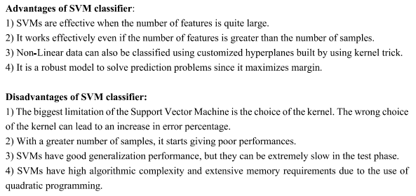

**Logistic regression** is a statistical method used for binary classification. It is a type of regression analysis that is well-suited for predicting the probability of a binary outcome (1/0, Yes/No, True/False) based on one or more predictor variables. It's called "logistic" because it uses the logistic function to model the relationship between the predictors and the binary response variable. The logistic function, also known as the sigmoid function, transforms the linear combination of predictor variables into a value between 0 and 1, which can be interpreted as a probability.

Here are some top interview questions and answers related to logistic regression:

* What is the difference between linear regression and logistic regression?
  + Linear regression is used for predicting continuous numeric outcomes, while logistic regression is used for predicting binary categorical outcomes.
* What is the logistic function (sigmoid function), and how is it used in logistic regression?
  + The logistic function is an S-shaped curve that maps any real-valued number to a value between 0 and 1. It's used in logistic regression to transform the linear combination of predictor variables into a probability.
* What is the purpose of the odds ratio in logistic regression?
  + The odds ratio measures the odds of the event occurring (in binary classification) compared to the odds of the event not occurring. It's used to understand the impact of predictor variables on the likelihood of the outcome.
* What is the cost function in logistic regression, and why is it used?
  + The cost function (or loss function) in logistic regression is typically the log-likelihood or cross-entropy loss. It measures the error between predicted probabilities and actual outcomes. The model tries to minimize this cost function during training to improve its predictive accuracy.
* What are the assumptions of logistic regression?
  + Logistic regression assumes that the relationship between the predictor variables and the log-odds of the outcome is linear. It also assumes independence of errors and no multicollinearity.
* How do you deal with multicollinearity in logistic regression?
  + Multicollinearity occurs when predictor variables are highly correlated. To address it, you can remove one of the correlated variables, combine them, or use regularization techniques like L1 or L2 regularization.
* What is the purpose of regularization in logistic regression, and how does it work?
  + Regularization is used to prevent overfitting in logistic regression by adding a penalty term to the cost function. L1 regularization encourages sparsity, and L2 regularization penalizes large coefficients.
* What is the ROC curve in the context of logistic regression?
  + The ROC (Receiver Operating Characteristic) curve is a graphical representation of a model's performance in binary classification. It shows the trade-off between the true positive rate and false positive rate at different probability thresholds.
* What is AUC, and why is it used with ROC curves?
  + AUC (Area Under the ROC Curve) is a single scalar value that represents the overall performance of a logistic regression model. It quantifies the model's ability to distinguish between positive and negative cases.
* How do you evaluate the performance of a logistic regression model?
  + Common evaluation metrics include accuracy, precision, recall, F1 score, ROC-AUC, and the confusion matrix.

**A decision tree** is a supervised machine learning algorithm that is used for both classification and regression tasks. It is a graphical representation of a decision-making process, where each internal node represents a feature or attribute, each branch represents a decision rule, and each leaf node represents the outcome or class label. Decision trees are particularly popular because they are easy to understand and interpret, and they can handle both numerical and categorical data.

Here are some top interview questions and answers related to decision trees:

* What is a decision tree?
  + Answer: A decision tree is a tree-like structure used in machine learning for decision-making. It's a flowchart-like model where each internal node represents a feature or attribute, each branch represents a decision rule, and each leaf node represents a class label or prediction.
* What is the purpose of decision trees in machine learning?
  + Answer: Decision trees are used for both classification and regression tasks. They help make decisions by splitting data into subsets based on the values of input features, leading to a hierarchy of decisions and ultimately a prediction or classification.
* How is a decision tree built?
  + Answer: Decision trees are built using a top-down, recursive process called recursive partitioning. At each step, the algorithm selects the best feature to split the data based on criteria such as information gain, Gini impurity, or mean squared error, until a stopping condition is met.
* What is overfitting in decision trees, and how can it be prevented?
  + Answer: Overfitting occurs when a decision tree is too complex and fits the training data noise rather than the underlying patterns. To prevent overfitting, you can use techniques like pruning, limiting the tree depth, or setting a minimum number of samples required to split a node.
* What are some common impurity measures used in decision tree algorithms?
  + Answer: Common impurity measures include Gini impurity, entropy, and classification error. These measures are used to evaluate the quality of a split in the decision tree.
* What is pruning in decision trees?
  + Answer: Pruning is a technique used to reduce the size of a decision tree by removing branches that provide little predictive power. It helps to prevent overfitting and improve the tree's generalization to unseen data.
* Can decision trees handle categorical data, and how is it done?
  + Answer: Yes, decision trees can handle categorical data. One common approach is to use techniques like one-hot encoding to convert categorical variables into a binary format, which allows the tree to work with them effectively.
* What are some advantages of decision trees in machine learning?
  + Answer: Advantages of decision trees include simplicity, interpretability, handling both numerical and categorical data, and the ability to capture nonlinear relationships in the data.
* What are some limitations of decision trees?
  + Answer: Limitations of decision trees include the tendency to overfit, sensitivity to small variations in the data, and difficulty in handling imbalanced datasets.
* How do you choose between different types of decision tree algorithms (e.g., CART, ID3, C4.5, Random Forest)?
  + Answer: The choice of algorithm depends on the specific problem, the type of data, and the desired model characteristics. CART is versatile and commonly used, while Random Forest combines multiple trees for improved performance and can be a good choice for many problems.
* What is ID3, and how does it work?
  + Answer: ID3 is a decision tree algorithm that uses a top-down, recursive approach to construct a decision tree. It selects attributes at each node that best splits the dataset based on information gain. The goal is to create a tree that maximizes the separation of classes or minimizes impurity in the leaves.
* What is information gain in ID3?
  + Answer: Information gain is a metric used by ID3 to measure the reduction in uncertainty or entropy when a dataset is split based on a particular attribute. It quantifies how well an attribute separates the data into distinct classes. Attributes with higher information gain are preferred for splitting.
* What are the limitations of ID3?
  + Answer: ID3 has some limitations, such as:
    - It only handles categorical data, not continuous attributes.
    - It can create unbalanced trees, which may not generalize well.
    - It is sensitive to small variations in the data, leading to different tree structures.
    - It does not handle missing values effectively.
* What is the main advantage of using decision trees in general?
  + Answer: Decision trees are interpretable, easy to understand, and can handle both classification and regression tasks. They are useful for feature selection and can be visualized, making them valuable tools for decision-making.
* How does ID3 handle overfitting?
  + Answer: ID3 is prone to overfitting because it can create deep, complex trees. To mitigate overfitting, pruning techniques can be applied to remove branches that do not significantly improve the tree's performance. Post-pruning or using more advanced tree algorithms like C4.5 can help address this issue.
* What is the difference between ID3 and C4.5?
  + Answer: C4.5 is an improvement over ID3 and addresses some of its limitations. Unlike ID3, C4.5 can handle both categorical and continuous data, and it uses gain ratio instead of information gain for attribute selection. Additionally, C4.5 includes a pruning step to reduce overfitting.
* Can you explain how the concept of entropy is used in ID3?
  + Answer: Entropy is a measure of impurity or disorder in a dataset. In ID3, it is used to calculate the uncertainty in a dataset before and after splitting it using a particular attribute. The reduction in entropy, known as information gain, is used to determine which attribute is the best choice for splitting the data.
* What are the steps involved in building a decision tree with ID3?
  + Answer: The steps typically involved in building a decision tree with ID3 are:
    - Calculate the entropy of the target variable.
    - For each attribute, calculate the information gain.
    - Select the attribute with the highest information gain as the node's decision attribute.
    - Recursively apply the process to each branch until a stopping criterion is met (e.g., a maximum depth is reached, or no more attributes are available).

What is the difference between CART and ID3/C4.5?

* CART uses Gini impurity for classification and mean squared error for regression, while ID3 and C4.5 use information gain and gain ratio. CART also constructs binary trees, while ID3 and C4.5 can create multi-branching trees.

How does CART handle overfitting?

* CART can overfit the training data by creating a very deep tree. To prevent overfitting, you can apply techniques like limiting the tree depth, setting a minimum number of samples required for a node to split, or using pruning methods to remove branches that don't significantly improve predictive accuracy.

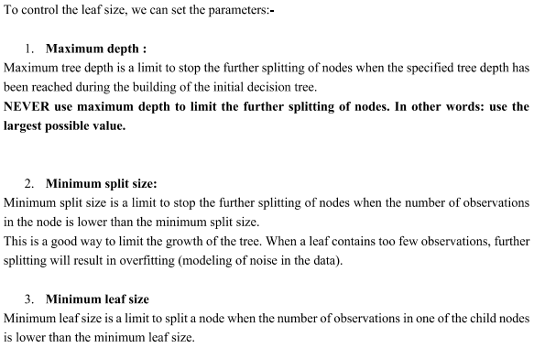

**A Random Forest** is an ensemble learning technique in machine learning that is used for both classification and regression tasks. It is built upon the foundation of decision trees and combines multiple decision trees to make more accurate and robust predictions. Random Forests are widely used in various applications, including data mining, image classification, and bioinformatics.

Here are some top interview questions and their answers related to Random Forest:

* What is a Random Forest, and how does it work?
  + Answer: A Random Forest is an ensemble learning method that creates a multitude of decision trees during training and combines their outputs to make predictions. It reduces overfitting and increases the model's generalization ability by aggregating the results of multiple trees.
* What is the difference between a decision tree and a Random Forest?
  + Answer: Decision trees are individual models, whereas Random Forest is an ensemble of multiple decision trees. Random Forest combines the predictions of these trees to improve accuracy and reduce overfitting.
* Why is it called a "Random" Forest?
  + Answer: The "random" aspect comes from the fact that a Random Forest introduces randomness during the tree-building process. It selects a random subset of features and a random subset of the training data for each tree, making the model more diverse and less prone to overfitting.
* What is the purpose of feature bagging in a Random Forest?
  + Answer: Feature bagging, or random feature selection, is a technique used in Random Forests to prevent strong predictors from dominating the decision-making in individual trees. It ensures that each tree is trained on a different set of features, adding to the diversity of the ensemble.
* How does a Random Forest handle missing data?
  + Answer: Random Forests can handle missing data by imputing missing values with the mean (for numerical features) or the mode (for categorical features) of the available data. The algorithm doesn't require imputation for prediction but can still use the information from the incomplete data.
* What are the advantages of using Random Forests?
  + Answer: Random Forests offer several advantages, including high accuracy, resistance to overfitting, robustness to outliers, handling of large datasets with many features, and the ability to measure feature importance.
* What is out-of-bag error, and how is it used in Random Forests?
  + Answer: Out-of-bag (OOB) error is an estimate of the model's performance on unseen data. It is calculated by evaluating each tree in the forest on data it didn't see during training (the samples not included in its bootstrap sample). OOB error can be used to assess the model's accuracy without the need for a separate validation dataset.
* Can you explain the concept of feature importance in a Random Forest?
  + Answer: Feature importance in a Random Forest measures the contribution of each feature to the model's predictive performance. It is computed based on the decrease in impurity (e.g., Gini impurity) achieved by splitting on that feature across all trees. Features that result in higher impurity reduction are considered more important.
* What are some potential drawbacks of using Random Forests?
  + Answer: While Random Forests are a powerful algorithm, they do have some limitations, including increased memory usage, longer training times with a large number of trees, and the potential for decreased interpretability compared to a single decision tree.
* When would you choose a Random Forest over other machine learning algorithms?
  + Answer: Random Forests are a good choice when you need a robust, high-performance model without fine-tuning. They work well for both classification and regression tasks, particularly in situations where interpretability is less critical.

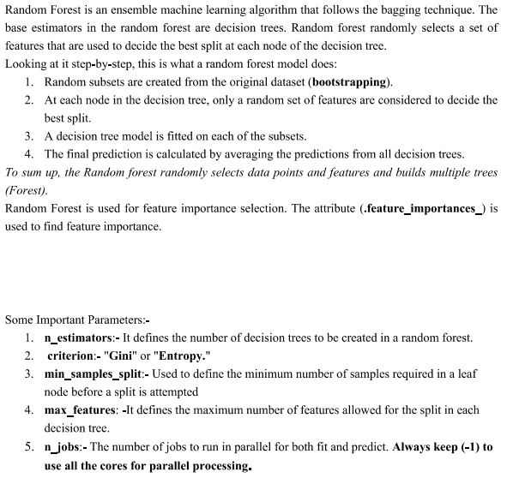

**The bias-variance tradeoff** is a fundamental concept in machine learning and statistics that deals with the balance between two types of errors that a model can make: bias and variance. It's essential to understand this tradeoff to build models that generalize well to unseen data.

* What is Bias?
  + Bias is the error introduced by approximating a real-world problem with a simplified model. It's the assumption made by the model that may not hold in the real data.
  + High bias can lead to underfitting, where the model is too simple to capture the underlying patterns in the data.
  + Commonly, linear models like simple linear regression tend to have high bias.
* What is Variance?
  + Variance is the error introduced by the model's sensitivity to small fluctuations in the training data. It's the model's ability to fit noise in the data.
  + High variance can lead to overfitting, where the model is too complex and fits the training data too closely, failing to generalize to new, unseen data.
  + Complex models, such as deep neural networks, can have high variance.

The tradeoff between bias and variance can be summarized as follows:

* A high-bias model has low complexity and makes strong assumptions about the data. It is simple but may not capture the underlying patterns. This leads to underfitting.
* A high-variance model has high complexity and is very flexible, fitting the training data closely. However, it may fail to generalize to new data, leading to overfitting.

Balancing the bias-variance tradeoff is crucial for building models that generalize well. Here are some common interview questions and answers related to the bias-variance tradeoff:

1. Why is the bias-variance tradeoff important in machine learning?

* The bias-variance tradeoff is essential because it helps us find the right level of model complexity. If we understand this tradeoff, we can create models that both capture underlying patterns and generalize well to unseen data.

2. How can you tell if your model has a high bias or high variance problem?

* High bias is indicated by poor performance on both the training and testing data. High variance is indicated by a significant gap between training and testing performance, with the model performing well on training data but poorly on testing data.

3. What are some techniques to reduce bias in a model?

* To reduce bias, you can increase model complexity, use more features, or employ more advanced algorithms. For example, moving from linear regression to polynomial regression can reduce bias.

4. What are some techniques to reduce variance in a model?

* To reduce variance, you can simplify the model, use regularization techniques (e.g., L1 or L2 regularization), or increase the amount of training data. Cross-validation can also help identify high-variance models.

5. Can you explain cross-validation's role in addressing the bias-variance tradeoff?

* Cross-validation is a technique used to estimate a model's performance on unseen data. It helps in identifying whether a model has a bias or variance problem. By splitting the data into multiple subsets and training on different combinations, cross-validation provides insights into a model's generalization capabilities.

6. Is it always better to reduce bias and variance simultaneously?

* Not necessarily. There is a tradeoff between bias and variance, and it's often a matter of finding the right balance for a specific problem. In some cases, reducing one may increase the other. It depends on the data and the problem you're trying to solve.

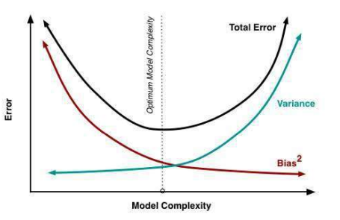

**Ensemble methods** are machine learning techniques that combine the predictions of multiple base models (usually called "weak learners" or "base classifiers/regressors") to create a stronger, more robust predictive model. The idea behind ensemble methods is that by aggregating the predictions of multiple models, you can often achieve better performance than using a single model. Ensemble methods are widely used in data science and machine learning because they help improve predictive accuracy and reduce overfitting.

There are several popular ensemble methods, with the most common ones being:

* **Bagging (Bootstrap Aggregating**): Bagging involves training multiple base models on different subsets of the training data (typically through bootstrapping, which means sampling the data with replacement). The predictions of these models are then combined, often by taking a majority vote (for classification) or averaging (for regression).
* **Random Forest:** Random Forest is a specific ensemble method that uses decision trees as base models. It combines multiple decision trees, each trained on a random subset of features and data, and then aggregates their predictions. Random Forests are known for their robustness and generalization.
* **Boosting**: Boosting methods, like AdaBoost, Gradient Boosting, and XGBoost, work by sequentially training base models. Each new model focuses on the examples that the previous models struggled with, assigning them higher weights. This helps correct the errors made by previous models.
* **Stacking:** Stacking, or Stacked Generalization, involves training multiple base models and then training a meta-model (or "blender") on top of these base models' predictions. The meta-model learns how to best combine the base models' predictions.
* Voting: Voting ensembles combine the predictions of multiple base models by having them "vote" on the final prediction. This can be done by majority voting (for classification) or averaging (for regression).

Here are some common interview questions and answers related to ensemble methods:

1. What are ensemble methods, and why are they used in machine learning?

Answer: Ensemble methods are techniques that combine the predictions of multiple models to improve overall predictive performance. They are used in machine learning to reduce overfitting, enhance model robustness, and boost predictive accuracy by harnessing the strengths of different models.

2. Explain the difference between bagging and boosting.

Answer: Bagging (Bootstrap Aggregating) involves training multiple base models independently on different subsets of the data and then combining their predictions, typically through majority voting or averaging. Boosting, on the other hand, trains base models sequentially, with each subsequent model focusing on the mistakes made by the previous ones. It assigns higher weights to misclassified examples, aiming to correct errors.

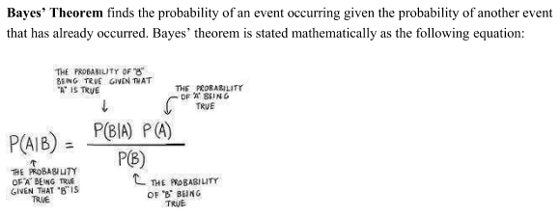

**The Naive Bayes classifier** is a simple and probabilistic machine learning algorithm used for classification tasks, particularly in text classification and spam detection. It's based on Bayes' theorem and is "naive" because it makes the assumption that features are conditionally independent, meaning that the presence or absence of a particular feature is unrelated to the presence or absence of any other feature given the class variable.

Here are some common interview questions and answers related to the Naive Bayes classifier:

* What is Bayes' theorem?
  + Bayes' theorem is a fundamental theorem in probability and statistics that describes the probability of an event, based on prior knowledge of conditions related to the event.
* Why is it called "naive"?
  + It's called "naive" because it makes the simplifying assumption that features are conditionally independent, which is often not the case in real-world data. This simplification helps make the algorithm computationally efficient.
* In which applications is Naive Bayes commonly used?
  + Naive Bayes is commonly used in text classification, spam detection, sentiment analysis, and recommendation systems.
* What are the different types of Naive Bayes classifiers?
  + There are three main types: Gaussian Naive Bayes for continuous data, Multinomial Naive Bayes for discrete data (common in text classification), and Bernoulli Naive Bayes for binary data.
* How does the Naive Bayes algorithm work?
  + The algorithm calculates the posterior probability of a class given a set of features using Bayes' theorem. It selects the class with the highest posterior probability as the predicted class.
* What is Laplace smoothing (additive smoothing) in Naive Bayes?
  + Laplace smoothing is a technique used to handle the problem of zero probabilities. It adds a small value (usually 1) to all counts to ensure that no feature has a probability of zero for a given class.
* Can Naive Bayes handle continuous and categorical features?
  + Yes, Naive Bayes can handle both continuous and categorical features. Gaussian Naive Bayes is suitable for continuous data, while Multinomial and Bernoulli Naive Bayes are commonly used for categorical data.
* What are the advantages of using Naive Bayes?
  + Naive Bayes is simple, computationally efficient, and works well for high-dimensional data. It often performs surprisingly well on text classification tasks.
* What are the limitations of Naive Bayes?
  + It makes a strong independence assumption that may not hold in some real-world scenarios. It can be sensitive to irrelevant features and is not ideal for tasks where feature dependencies are significant.
* Can Naive Bayes handle missing data?
  + Handling missing data in Naive Bayes can be tricky. One approach is to impute missing values or use techniques like mean imputation.
* How do you evaluate the performance of a Naive Bayes classifier?
  + Common evaluation metrics include accuracy, precision, recall, F1-score, and ROC-AUC, depending on the specific problem and the class distribution.
* What is the difference between Naive Bayes and other classification algorithms like Logistic Regression or Decision Trees?
  + Naive Bayes makes strong independence assumptions, which may or may not hold in real-world data. Logistic Regression and Decision Trees do not make this assumption and are more flexible in capturing complex relationships in the data.

**A confusion matrix** is a performance measurement tool commonly used in machine learning and statistics to evaluate the performance of a classification algorithm. It provides a summary of the model's predictions and their actual outcomes. It is particularly useful for binary classification problems, where there are two possible classes (e.g., positive and negative) but can also be extended to multi-class classification.

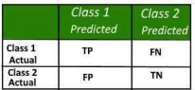

A confusion matrix typically consists of four values:

* True Positive (TP): The number of instances correctly predicted as positive by the model.
* True Negative (TN): The number of instances correctly predicted as negative by the model.
* False Positive (FP): The number of instances incorrectly predicted as positive (Type I error).
* False Negative (FN): The number of instances incorrectly predicted as negative (Type II error).

Now, let's cover some top interview questions and answers related to confusion matrices:

* 1 What is the purpose of a confusion matrix?  
  Answer: The confusion matrix is used to evaluate the performance of a classification model by comparing its predictions to the actual outcomes, helping to assess the model's accuracy, precision, recall, and other metrics.
* 2 Explain True Positive (TP) and False Positive (FP).  
  Answer: True Positive (TP) represents the number of instances that were correctly predicted as positive by the model. False Positive (FP) represents the number of instances that were incorrectly predicted as positive when they were actually negative. FP is also known as a Type I error.
* 3 Define True Negative (TN) and False Negative (FN).  
  Answer: True Negative (TN) represents the number of instances that were correctly predicted as negative by the model. False Negative (FN) represents the number of instances that were incorrectly predicted as negative when they were actually positive. FN is also known as a Type II error.
* 4 What is accuracy, and how is it calculated using a confusion matrix?  
  Answer: Accuracy is a measure of how many predictions a model got correct overall. It is calculated as (TP + TN) / (TP + TN + FP + FN). It measures the ratio of correctly predicted instances to the total number of instances.
* 5 What are precision and recall, and how are they calculated from a confusion matrix?  
  Answer: Precision is the ratio of true positives to the total number of positive predictions, and it's calculated as TP / (TP + FP). Recall, also known as sensitivity or true positive rate, is the ratio of true positives to the total number of actual positive instances, and it's calculated as TP / (TP + FN).

6 How can you use a confusion matrix to choose an appropriate threshold for a binary classifier?  
Answer: You can vary the threshold used for classifying instances as positive or negative and analyze how it affects the trade-off between precision and recall. By adjusting the threshold, you can find a balance that suits your specific application, considering false positives and false negatives.

* 7 What is the F1 score, and how is it related to precision and recall?  
  Answer: The F1 score is a single metric that combines precision and recall into one value. It is calculated as 2 * (precision * recall) / (precision + recall). It provides a balance between precision and recall, making it useful when you want to consider both false positives and false negatives.

8 Explain the difference between Type I and Type II errors in the context of a confusion matrix.  
Answer: Type I error, represented by False Positives (FP), occurs when the model predicts an instance as positive when it is actually negative. Type II error, represented by False Negatives (FN), occurs when the model predicts an instance as negative when it is actually positive.

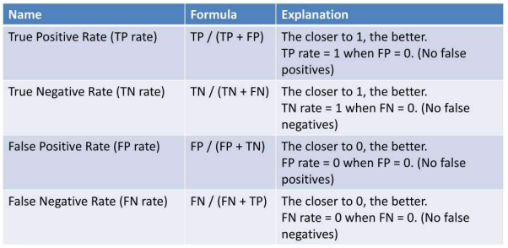

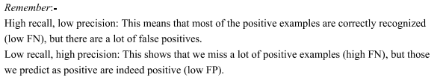

* **What is RandomizedSearchCV?**
  + RandomizedSearchCV is a method for hyperparameter tuning that randomly samples hyperparameters from a predefined distribution. It performs a specified number of iterations and evaluates the model's performance with each combination of hyperparameters.
  + Unlike GridSearchCV, which exhaustively searches through all possible hyperparameter combinations, RandomizedSearchCV narrows down the search space by randomly sampling hyperparameters. This is particularly useful when the hyperparameter space is vast and you want to balance computational cost with search effectiveness.
* **What is GridSearchCV?**
  + GridSearchCV is a method for hyperparameter tuning that exhaustively searches through a pre-defined set of hyperparameters. It evaluates the model's performance for every possible combination of hyperparameters within the specified grid.
  + While GridSearchCV is more comprehensive in searching the hyperparameter space, it can be computationally expensive, especially when there are many hyperparameters and potential values to consider.

Top Interview Questions and Answers:

* What is the main difference between RandomizedSearchCV and GridSearchCV?
  + RandomizedSearchCV randomly samples hyperparameters from predefined distributions, while GridSearchCV exhaustively searches through all possible combinations.
* When would you prefer to use RandomizedSearchCV over GridSearchCV, and vice versa?
  + Use RandomizedSearchCV when the hyperparameter space is large and computational resources are limited. Use GridSearchCV when you have a smaller, well-defined hyperparameter space and want a more comprehensive search.
* What are the advantages of RandomizedSearchCV?
  + It is computationally more efficient when dealing with a large hyperparameter space.
  + It can find good hyperparameters faster than random guessing.
* What are the advantages of GridSearchCV?
  + It guarantees that all combinations within the grid will be evaluated, ensuring the best possible hyperparameters are found.
  + It is easy to set up and understand.
* What is cross-validation in the context of hyperparameter tuning?
  + Cross-validation is a technique to assess how well a model will generalize to an independent dataset. It involves splitting the dataset into multiple subsets (folds), training the model on some folds and testing on others to evaluate its performance. Cross-validation helps prevent overfitting and provides a more robust estimate of a model's performance.
* Can you combine RandomizedSearchCV and GridSearchCV techniques for hyperparameter tuning?
  + Yes, you can use a combination of both methods. You might start with RandomizedSearchCV to quickly narrow down the hyperparameter space and identify promising combinations. Then, you can follow up with GridSearchCV to perform a more fine-grained search in the vicinity of the promising combinations.

**Multicollinearity** is a statistical phenomenon that occurs when two or more independent variables in a regression model are highly correlated with each other. In other words, it is the presence of strong linear relationships between predictors. Multicollinearity can cause problems in regression analysis and can make it difficult to determine the individual effect of each independent variable on the dependent variable.

Here are some top interview questions and answers related to multicollinearity:

* What are the consequences of multicollinearity?  
  Multicollinearity can lead to several issues:
  + It makes it difficult to interpret the individual effect of each independent variable.
  + Standard errors of the regression coefficients become inflated, making p-values unreliable.
  + The overall model may still be good for prediction, but it's harder to understand which predictors are essential.
  + It can lead to unstable coefficients, making the model sensitive to small changes in the data.
* How can you detect multicollinearity in a regression model?  
  You can detect multicollinearity using the following methods:
  + Correlation matrix: Check the correlation between independent variables. High correlations (usually above 0.7) can be indicative of multicollinearity.
  + Variance Inflation Factor (VIF): Calculate the VIF for each independent variable. A high VIF (typically above 10) suggests multicollinearity.
  + Tolerance: Tolerance is the inverse of VIF. A low tolerance indicates multicollinearity.
* How can you address multicollinearity?  
  There are several ways to address multicollinearity:
  + Remove one of the correlated variables: If two variables are highly correlated, you can remove one of them.
  + Combine correlated variables: Create new variables by combining or averaging the correlated ones.
  + Ridge or Lasso regression: These regularization techniques can help reduce multicollinearity.
  + Principal Component Analysis (PCA): Transform the variables into a set of uncorrelated variables using PCA.
* Can you have perfect multicollinearity?
  + Perfect multicollinearity occurs when one independent variable can be perfectly predicted by a linear combination of other variables in the model. This situation can make it impossible to estimate the regression coefficients. It often results from data errors or including variables that are linearly dependent.

**K-Nearest Neighbors (KNN**) is a simple and widely used classification algorithm in machine learning. It is a supervised learning algorithm that can be used for both classification and regression tasks. The basic idea behind KNN is to classify a data point based on the majority class of its 'k' nearest neighbors in the feature space. In other words, if you want to classify a new data point, you find the 'k' data points from the training dataset that are closest to the new point, and the class that is most common among those 'k' neighbors is assigned to the new point.

Here are some common interview questions and answers about KNN:

* How does the KNN algorithm work?
  + Answer: KNN works by finding the 'k' nearest data points to a given data point in the feature space. It then assigns the class that is most common among those 'k' neighbors to the data point.
* What is the significance of the 'k' parameter in KNN?
  + Answer: The 'k' parameter in KNN specifies the number of nearest neighbors to consider when making a classification decision. A smaller 'k' can make the model more sensitive to noise, while a larger 'k' can make it more robust but potentially lose fine-grained details.
* How do you choose the optimal value of 'k' in KNN?
  + Answer: The choice of 'k' is often determined through techniques like cross-validation. You can try different values of 'k' and measure the algorithm's performance using a validation set to find the one that provides the best accuracy.
* What are the distance metrics commonly used in KNN?
  + Answer: The most common distance metrics used in KNN are Euclidean distance, Manhattan distance, and Minkowski distance. The choice of distance metric depends on the nature of the data and the problem.
* What are the advantages of KNN?
  + Answer: KNN is simple to understand and implement. It can be used for both classification and regression tasks. It's non-parametric, meaning it doesn't make assumptions about the underlying data distribution.
* What are the limitations of KNN?
  + Answer: KNN can be computationally expensive, especially when dealing with large datasets. It's sensitive to the choice of 'k' and the distance metric. It doesn't perform well when there are irrelevant features in the dataset, and it can be sensitive to noise in the data.
* How does KNN handle categorical features in the dataset?
  + Answer: For categorical features, you can use distance metrics like Hamming distance or custom distance functions that are appropriate for the specific data type. You'll need to preprocess and encode categorical data before using KNN.
* What is the difference between KNN and K-Means clustering?
  + Answer: KNN is a supervised learning algorithm used for classification and regression, while K-Means is an unsupervised clustering algorithm used for grouping data points into clusters based on similarity.
* When would you prefer using KNN over other classification algorithms like Decision Trees or SVM?
  + Answer: KNN can be a good choice when you have a small to medium-sized dataset, and you want a simple and interpretable model. It can be effective when the decision boundary is not easily defined by a parametric model.
* Can KNN handle imbalanced datasets?
  + Answer: KNN can be sensitive to imbalanced datasets. In such cases, you may need to adjust the class weights or use oversampling/undersampling techniques to address the imbalance.

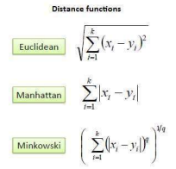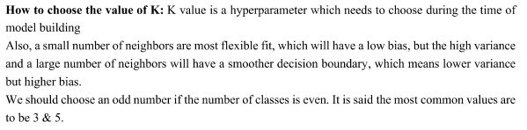

**PCA, or Principal Component Analysis,** is a dimensionality reduction technique used in statistics and machine learning to transform data into a lower-dimensional space while preserving as much of the original data's variance as possible. It does this by identifying and creating new axes, called principal components, that capture the most significant variations in the data. PCA is commonly used for data preprocessing, visualization, noise reduction, and feature selection in various fields, including image and speech recognition, genetics, and finance.

Here are some common interview questions and answers related to PCA:

* How does PCA work?
  + Answer: PCA works by finding the eigenvectors and eigenvalues of the data's covariance matrix. The eigenvectors represent the principal components, and the eigenvalues indicate the proportion of data variance each component captures. The components are ordered by eigenvalue magnitude.
* What is the importance of eigenvalues and eigenvectors in PCA?
  + Answer: Eigenvalues represent the amount of variance explained by each principal component, and eigenvectors are the directions in which the data varies the most. The eigenvalues help in choosing the most significant components, and the eigenvectors are the axes along which the data will be transformed.
* How do you decide the number of principal components to retain in PCA?
  + Answer: The number of principal components to retain is typically chosen based on the cumulative explained variance. You can set a threshold (e.g., 95% of variance retained) or use techniques like scree plots or cross-validation to determine the appropriate number.
* What is the difference between PCA and Linear Discriminant Analysis (LDA)?
  + Answer: PCA is an unsupervised technique used for dimensionality reduction and data visualization. LDA is a supervised technique that maximizes the separation between classes in classification problems. PCA focuses on data variance, while LDA considers class separability.
* What are the limitations of PCA?
  + Answer: PCA assumes linearity, which may not hold in all cases. It also does not consider class labels or target variables, making it less suitable for supervised learning tasks. Additionally, it can be sensitive to the scaling of the data.
* Can PCA be used for feature selection?
  + Answer: Yes, PCA can be used for feature selection by selecting a subset of the principal components. This can help reduce dimensionality while retaining the most important features of the data.
* Explain the concept of whitening in PCA.
  + Answer: Whitening is a step in PCA where the transformed data is decorrelated and rescaled to have unit variance along each principal component. It ensures that the transformed features are uncorrelated and have equal importance.
* Give an example of a real-world application of PCA.
  + Answer: PCA is used in facial recognition systems to reduce the dimensionality of face images, making it easier to compare and recognize faces. It is also used in finance to identify patterns in stock market data and in genetics for analyzing gene expression profiles.

**Outliers** are data points that significantly differ from the majority of the data in a dataset. They can be either much smaller or much larger than the other data points and can introduce noise and skew the results of statistical analyses. Outliers can occur for various reasons, such as errors in data collection, natural variation, or truly exceptional observations.

* How can you detect outliers in a dataset?
  + Answer: There are several methods to detect outliers, including:
    - Visual inspection using box plots or scatter plots.
    - Statistical methods like the Z-score or the IQR (Interquartile Range) method.
    - Machine learning algorithms, such as clustering or isolation forests.
    - Domain knowledge and business context can also be valuable in identifying outliers.
* What are some techniques for handling outliers?
  + Answer: Handling outliers depends on the specific context, but common techniques include:
    - Removing outliers if they are due to data entry errors.
    - Transforming the data (e.g., log transformation) to reduce the impact of outliers.
    - Winsorizing, which caps extreme values to a predetermined percentile.
    - Using robust statistical methods that are less sensitive to outliers.
* Can you explain the concept of the Z-score and how it's used to detect outliers?
  + Answer: The Z-score measures how many standard deviations a data point is away from the mean. To detect outliers using Z-scores, you typically set a threshold (e.g., Z > 3 or Z < -3) and consider data points that exceed this threshold as outliers. It's a straightforward method for identifying extreme values in a dataset.

**Encoding techniques** are important because most machine learning algorithms require numerical input data, and categorical data must be transformed into a suitable format.

Here are some common encoding techniques in machine learning:

* Label Encoding:
  + Label encoding involves assigning a unique integer to each category in a categorical variable.
  + It is suitable for ordinal data where there is a natural order among the categories.
  + For example, in the "size" feature, "small," "medium," and "large" can be encoded as 0, 1, and 2.
* One-Hot Encoding:
  + One-hot encoding creates binary columns for each category in a categorical variable, where a "1" indicates the presence of that category, and a "0" indicates its absence.
  + It is used for nominal data where there is no inherent order among the categories.
  + For example, in the "color" feature, "red," "blue," and "green" would become three binary columns.
* Binary Encoding:
  + Binary encoding combines the benefits of label and one-hot encoding. It assigns a unique binary code to each category and represents it in binary format.
  + It is more space-efficient than one-hot encoding and can work well for high-cardinality categorical variables.
* Count Encoding:
  + Count encoding replaces each category with the count of how often it appears in the dataset.
  + It can be useful when the frequency of a category is relevant to the problem.
* Target Encoding (Mean Encoding):
  + Target encoding involves replacing each category with the mean of the target variable for that category.
  + It is useful for classification tasks, but it can lead to overfitting if not used carefully.
* Frequency Encoding:
  + Frequency encoding replaces categories with their frequency (or percentage) of occurrence in the dataset.
  + It can be useful when the frequency of a category is relevant to the problem.

**Correlation** in machine learning refers to the statistical measure of the extent to which two variables are related. It quantifies the degree to which changes in one variable are associated with changes in another variable. Correlation is often used to identify patterns and relationships in data, which can be valuable in feature selection, data analysis, and model building. The most commonly used measure of correlation is the Pearson correlation coefficient.

Here are some top interview questions and answers related to correlation in machine learning:

* What is the Pearson correlation coefficient, and how is it calculated?  
  Answer: The Pearson correlation coefficient, also known as Pearson's r, is a measure of linear correlation between two continuous variables. It ranges from -1 (perfect negative correlation) to 1 (perfect positive correlation), with 0 indicating no linear correlation. It is calculated as the covariance of the two variables divided by the product of their standard deviations.
* What is the significance of a correlation coefficient value of 0?  
  Answer: A correlation coefficient of 0 indicates that there is no linear relationship between the two variables. In other words, changes in one variable do not predict changes in the other variable. However, it's essential to note that there might still be non-linear relationships or other forms of correlation not captured by the Pearson coefficient.
* What is the difference between positive and negative correlation?  
  Answer: Positive correlation means that as one variable increases, the other tends to increase as well. Negative correlation means that as one variable increases, the other tends to decrease. A correlation coefficient of +1 represents a perfect positive correlation, while -1 represents a perfect negative correlation.
* What are some limitations of the Pearson correlation coefficient?  
  Answer: Pearson's correlation assumes a linear relationship between variables, which may not be true for all datasets. It also assumes that the data is normally distributed. Outliers can significantly affect the correlation coefficient. Additionally, it only measures linear associations and may not capture non-linear relationships.
* Can you have a high correlation without causation?  
  Answer: Yes, a high correlation does not imply causation. Correlation only measures the strength and direction of a relationship between variables but does not establish a cause-and-effect relationship. Causation requires further experimentation and evidence to support it.

**What are the different types of feature selection techniques?**

A. Here are some ways of selecting the best features out of all the features to increase the model performance, as the irrelevant features decrease the model performance of the machine learning or deep learning model.  
– Filter Methods: Select features based on statistical measures such as correlation or chi-squared test.For example- Correlation-based Feature Selection, chi2 test, SelectKBest, and ANOVA F-value.  
– Wrapper Methods: Select features by evaluating their combinations using a predictive model.For example- Recursive Feature Elimination, Backward Feature Elimination, Forward Feature Selection  
– Embedded Methods: Select features by learning their importance during model training.For example- Lasso Regression, Ridge Regression, and Random Forest.  
– Hybrid Methods: Combine the strengths of filter and wrapper methods. For Example- SelectFromModel  
– Dimensionality Reduction Techniques: Reduce the dimensionality of the dataset and select the most important features. For Example- pca, lda, and ica.

**Statistical tests** are used to make inferences and determine the significance of relationships or differences in data. These tests help data scientists and machine learning practitioners to assess the validity of their models, evaluate hypotheses, and make informed decisions. Here are some common interview questions and answers related to statistical tests in machine learning:

* What are the main types of statistical tests used in machine learning?
  + There are several types of statistical tests, including t-tests, chi-squared tests, ANOVA (Analysis of Variance), correlation tests, and non-parametric tests like the Wilcoxon signed-rank test. The choice of test depends on the specific problem and data characteristics.
* When should you use a t-test in machine learning?
  + A t-test is used to determine if there is a statistically significant difference between the means of two groups. It is commonly used in machine learning when comparing the performance of two models or assessing the impact of a feature on the target variable.
* Explain the chi-squared test and its application in machine learning.
  + The chi-squared test is used to test the independence of two categorical variables. In machine learning, it can be used to determine if there is a significant relationship between two categorical features or to assess the importance of categorical features in classification tasks.
* What is ANOVA, and how is it used in machine learning?
  + ANOVA (Analysis of Variance) is used to assess the differences in means among multiple groups. In machine learning, it can be used to compare the performance of more than two models or to determine the impact of categorical features with more than two levels on the target variable.
* How do you assess the significance of a correlation in machine learning?
  + Correlation tests, like Pearson's correlation coefficient or Spearman's rank correlation, are used to measure the strength and direction of the relationship between two continuous variables. A p-value is typically used to determine the significance of the correlation, with a low p-value indicating a strong correlation.
* What is a p-value, and how is it related to statistical tests in machine learning?
  + A p-value is a measure of the evidence against a null hypothesis. In machine learning, it is used to determine whether the results obtained from a statistical test are statistically significant. A low p-value (typically less than 0.05) suggests that the results are significant.
* What is the difference between parametric and non-parametric tests in machine learning?
  + Parametric tests assume that the data follows a specific distribution (e.g., normal distribution) and are used when certain assumptions are met. Non-parametric tests do not make strong distributional assumptions and are used when data is not normally distributed or when parametric assumptions are violated.

What is the significance of a Z-Score in hypothesis testing?

* Z-Scores are used to determine how far a sample mean is from the population mean. In hypothesis testing, if the Z-Score is very large, it suggests that the sample mean is significantly different from the population mean.

When should you use a Z-Test instead of a T-Test?

* You should use a Z-Test when you have a large sample size (typically, n > 30) and know the population standard deviation. Otherwise, a T-Test is more appropriate when the population standard deviation is unknown or when dealing with small sample sizes.

**Q1. How do you increase the accuracy of a regression model?**

A. There are several ways to increase the accuracy of a regression model, such as collecting more data, relevant feature selection, feature scaling, regularization, cross-validation, hyperparameter tuning, adjusting the learning rate, and ensemble methods like bagging, boosting, and stacking.

**Q2. How do you increase precision in machine learning?**

A. To increase precision in machine learning:  
– Improve the quality of training data.  
– Perform feature selection to reduce noise and focus on important information.  
– Optimize hyperparameters using techniques such as regularization or learning rate.  
– Use ensemble methods to combine multiple models and improve precision.  
– Adjust the decision threshold to control the trade-off between precision and recall.  
– Use different evaluation metrics to better understand the performance of the model.

**Ensemble techniques:**

**Stacking,** also known as stacked generalization, is an advanced ensemble technique in machine learning. It involves combining the predictions from multiple base models (learners) to create a meta-model that provides more accurate and robust predictions. Stacking is a form of model stacking, where you train a meta-model that takes the outputs of other models as input.

Here are some top interview questions and answers related to stacking in advanced ensemble techniques:

1. How does stacking differ from other ensemble methods like bagging and boosting?  
   Bagging and boosting use multiple instances of a single base model, while stacking uses multiple different models as base learners. Stacking aims to capture diverse patterns in data by combining predictions from different types of models.
2. What are the key components of a stacking ensemble?  
   The main components of a stacking ensemble include multiple base models, a meta-model, and a method to split the dataset into training and validation sets for the meta-model training.
3. How do you prevent overfitting in a stacked ensemble?  
   Overfitting can be controlled by using cross-validation when creating the meta-features. Instead of using the entire dataset for training the meta-model, you can use a portion of it and validate on the rest. Additionally, you can use regularization techniques on the meta-model.
4. Can you explain the process of creating a stacking ensemble?  
   To create a stacking ensemble, you first train multiple base models on the training data. Then, you use these base models to make predictions on the validation or test set. The predictions from the base models are used as input for the meta-model. The meta-model is trained on the same dataset with the true target values. Once the meta-model is trained, you can use it to make predictions on new data.
5. What is the advantage of stacking over using a single powerful model?  
   Stacking can often outperform a single powerful model because it combines the strengths of multiple models. It is especially effective when the base models have complementary strengths and weaknesses, leading to a more robust and accurate ensemble.
6. What are some popular algorithms used as base models in stacking ensembles?  
   Common choices for base models include decision trees, random forests, support vector machines, neural networks, k-nearest neighbors, and more. The choice of base models depends on the problem and the diversity of models you want to incorporate.
7. Are there any limitations or challenges associated with stacking ensembles?  
   One challenge is the increased complexity of model selection and hyperparameter tuning. Stacking can also be computationally expensive. Additionally, if the base models are poorly chosen or highly correlated, stacking may not yield significant improvements.
8. Can you explain the difference between stacking and blending?  
   Stacking and blending are similar concepts, but they differ in the way they combine base models. In stacking, the meta-model is trained on predictions from base models, while in blending, the predictions of base models are simply averaged or combined using a simple function.

Blending is a technique derived from Stacking Generalization. The only difference is that in Blending, the k-fold cross validation technique is not used to generate the training data of the meta-model.

1. When should you consider using stacking in a machine learning project?  
   Stacking is most useful when you have access to a diverse set of base models, and you want to boost the predictive power of your models, especially in cases where a single model may not perform well. It's valuable for improving model performance in complex and challenging tasks.

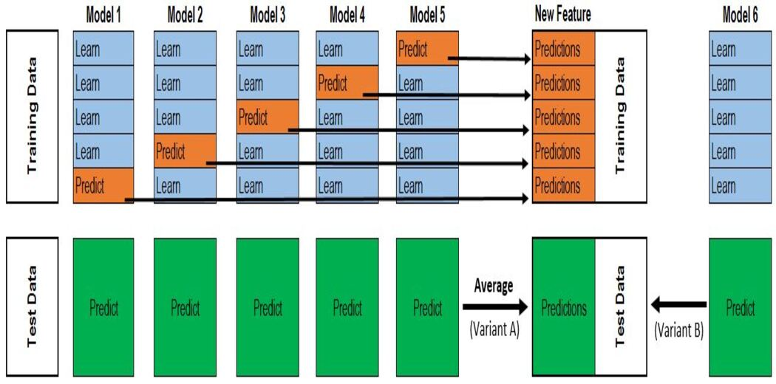

**Blending** is a popular advanced ensemble technique in machine learning, which involves combining the predictions of multiple machine learning models to improve the overall predictive performance. It's also known as stacking or meta-ensembling. Here's an explanation of blending and some top interview questions and answers related to it:

2. How does blending work?

* Blending typically involves the following steps:
  + Splitting the dataset into training and validation sets.
  + Training multiple base models on the training set.
  + Generating predictions from these base models using the validation set.
  + Using these predictions as input features for training a meta-model.
  + The meta-model is then used to make final predictions on new data.

3. What is the purpose of a meta-model in blending?

* The meta-model's purpose is to learn how to combine the predictions of the base models in a way that maximizes predictive performance. It finds the optimal weights for each base model's predictions to create a more accurate and robust ensemble prediction.

4. What are the advantages of blending?

* Blending offers several advantages, including improved model performance, better generalization, and the ability to combine diverse models. It can help mitigate the weaknesses of individual models.

5. What are the common algorithms used for blending?

* Various machine learning algorithms can be used as base models and meta-models in blending. Common choices include decision trees, random forests, gradient boosting machines, neural networks, and linear regression, among others.

6. What precautions should you take when implementing blending?

* Ensure that the base models are diverse and not highly correlated to make blending more effective. Be cautious about overfitting, and carefully validate your blending approach to avoid data leakage between the base models and the meta-model.

7. Can you explain the difference between bagging, boosting, and blending?

* Bagging (Bootstrap Aggregating) and boosting are ensemble techniques that focus on aggregating the predictions of multiple models, while blending combines the predictions of different models with a separate meta-model. Bagging uses multiple instances of the same base model trained on different subsets of the data, while boosting focuses on sequentially training models to correct the errors of the previous ones.

8. What are some alternative ensemble techniques to blending?

* Some alternatives to blending include bagging methods like Random Forest, boosting methods like AdaBoost and Gradient Boosting, and other advanced techniques like stacking (which is similar to blending but involves a more complex structure of multiple layers of base models and meta-models).

9. When should you consider using blending in a machine learning project?

* Blending can be useful when you've exhausted the potential of individual models, and you want to squeeze out additional performance gains. It's often employed in machine learning competitions and projects where the primary goal is to achieve the best possible predictive performance.

10. What challenges can arise when implementing blending in practice?

* Challenges include selecting the right base models, choosing an appropriate meta-model, dealing with computational complexity, and the risk of overfitting when tuning blending parameters. Additionally, blending may require a larger amount of data to be effective.

**Bagging**, short for Bootstrap Aggregating, is an advanced ensemble technique used in machine learning to improve the performance and robustness of predictive models. It works by combining multiple base models to create a more accurate and reliable ensemble model. Here's an explanation of bagging and some top interview questions and answers related to it:

2. How does bagging work?

* Bagging works by creating multiple subsets of the training data using bootstrap sampling (sampling with replacement). Each subset is used to train a separate base model. The final prediction is obtained by aggregating the predictions of these base models, typically through majority voting (for classification) or averaging (for regression).

3. What are the advantages of bagging?

* Bagging helps reduce overfitting by reducing the variance of the model.
* It improves predictive accuracy by combining the strengths of multiple base models.
* It can handle noisy or complex datasets effectively.

4. What are some popular algorithms that use bagging?

* Random Forest is a well-known ensemble method that employs bagging with decision trees as base models.
* Bagged Decision Trees are individual decision trees combined through bagging.

5. What's the difference between bagging and boosting?

* Bagging combines multiple models independently, while boosting combines them sequentially, with each model focusing on the errors made by the previous ones.
* Bagging aims to reduce variance and avoid overfitting, while boosting focuses on reducing bias and improving predictive accuracy.

6. What is out-of-bag (OOB) error in bagging?

* The out-of-bag error is the error rate of an ensemble model calculated on the data points not included in the training subset of a particular base model. OOB error is used to estimate the model's performance without the need for a separate validation set.

7. How does bagging handle imbalanced datasets?

* Bagging can help mitigate the issues related to imbalanced datasets by providing equal opportunities for minority and majority classes in different subsets, leading to better model generalization.

8. Can bagging be used with any base model?

* Bagging is a versatile technique and can be applied to a wide range of base models, including decision trees, support vector machines, neural networks, and more.

9. What are some potential drawbacks of bagging?

* Bagging may not improve the performance of an already highly accurate model significantly.
* It can increase computational complexity as it involves training multiple models.

10. What is the trade-off between bagging and variance?

* Bagging reduces the variance of the model by combining multiple base models, which tends to make the model more stable and less prone to overfitting. However, it might increase the bias slightly.

**Boosting** is an advanced ensemble technique in machine learning. Ensemble techniques combine the predictions of multiple machine learning models to improve the overall performance and accuracy of the model. Boosting, in particular, focuses on creating a strong predictive model by sequentially training weak learners and giving more weight to the misclassified instances in each iteration. Here are some top interview questions and answers on boosting in machine learning:

* How does boosting work?
  + Boosting works by training a series of weak models, such as decision trees, in sequence. After each iteration, it assigns higher weight to misclassified instances from the previous iteration. This way, boosting focuses on the examples that are challenging to classify.
* What are some popular boosting algorithms?
  + Some popular boosting algorithms include AdaBoost, Gradient Boosting (e.g., XGBoost, LightGBM), and CatBoost. These algorithms differ in the way they assign weights and update the models in each iteration.
* What is the key idea behind AdaBoost?
  + AdaBoost (Adaptive Boosting) assigns more weight to misclassified examples in each iteration, which allows weak models to focus on the challenging instances. The final prediction is a weighted combination of these weak models.
* What is the difference between bagging and boosting?
  + Bagging (Bootstrap Aggregating) creates multiple models in parallel and averages their predictions, while boosting creates models sequentially and gives more weight to misclassified instances. Boosting focuses on reducing bias, whereas bagging reduces variance.
* What is overfitting, and how does boosting address it?
  + Overfitting occurs when a model learns the training data too well, including noise. Boosting can mitigate overfitting because it prioritizes difficult-to-classify examples and gradually corrects misclassifications, leading to a more generalized model.
* Can boosting models handle noisy data?
  + Boosting models can handle noisy data to some extent. They are robust to noisy data, but extreme noise can still impact their performance. Data preprocessing and cleaning are often required for better results.
* What are the hyperparameters in boosting algorithms?
  + Hyperparameters in boosting algorithms include the learning rate, the number of boosting rounds (iterations), the base learner type (e.g., decision trees), and their depth. Tuning these hyperparameters is essential for optimal performance.

**XGBoost** is comparatively better than other techniques:

* Regularization:
  + Standard GBM implementation has no regularization like XGBoost.
  + Thus XGBoost also helps to reduce overfitting.
* Parallel Processing:
  + XGBoost implements parallel processing and is faster than GBM .
  + XGBoost also supports implementation on Hadoop.
* High Flexibility:
  + XGBoost allows users to define custom optimization objectives and evaluation criteria adding a whole new dimension to the model.
* Handling Missing Values:
  + XGBoost has an in-built routine to handle missing values.
* Tree Pruning:
  + XGBoost makes splits up to the max_depth specified and then starts pruning the tree backwards and removes splits beyond which there is no positive gain.
* Built-in Cross-Validation:
  + XGBoost allows a user to run a cross-validation at each iteration of the boosting process and thus it is easy to get the exact optimum number of boosting iterations in a single run.

**AdaBoost (Adaptive Boosting**):

* + Description: AdaBoost is an ensemble learning method that combines multiple weak classifiers to create a strong classifier. It assigns weights to data points and increases the importance of misclassified points in each iteration.
  + Interview Questions:
    - How does AdaBoost work?
      * AdaBoost combines multiple weak learners to create a strong learner. In each iteration, it assigns weights to data points, with higher weights on misclassified points. Weak learners are trained on this weighted data, and the process continues until a predefined number of iterations or until a perfect classifier is achieved.
    - What are the advantages of AdaBoost?
      * AdaBoost is simple, adaptive, and effective. It's less prone to overfitting and can be used with various base learners. It's also suitable for both classification and regression problems.

**XGBoost (Extreme Gradient Boosting)**:

* + Description: XGBoost is an optimized gradient boosting library that uses a gradient-based optimization algorithm. It is known for its speed and performance.
  + Interview Questions:
    - What is the key idea behind XGBoost?
      * XGBoost combines gradient boosting with regularized learning and parallel processing. It optimizes a cost function by using gradient information and is known for its efficiency.
    - What are some advantages of using XGBoost?
      * XGBoost is known for its speed, efficiency, and strong predictive performance. It includes features like handling missing values, built-in cross-validation, and support for custom loss functions.

**LightGBM (Light Gradient Boosting Machine)**:

* + Description: LightGBM is another gradient boosting framework designed for efficiency and speed. It uses a histogram-based approach for tree building.
  + Interview Questions:
    - How does LightGBM differ from traditional gradient boosting algorithms?
      * LightGBM uses a histogram-based approach for tree building, which reduces memory consumption and speeds up training. It also supports categorical features and parallel processing.
    - What is the trade-off between LightGBM's speed and memory consumption?
      * LightGBM's histogram-based approach improves speed but may increase memory consumption, as it needs to build histograms for features. This trade-off can be managed using parameters.

**CatBoost:**

* + Description: CatBoost is a gradient boosting library that is optimized for categorical features. It handles categorical data naturally without the need for manual encoding.
  + Interview Questions:
    - How does CatBoost handle categorical features?
      * CatBoost uses a method called "ordered boosting" and is capable of processing categorical features directly without the need for one-hot encoding or label encoding. It also handles missing values in categorical features.
    - What are some benefits of using CatBoost for gradient boosting?
      * CatBoost simplifies the preprocessing of categorical data, provides robust results, and can be faster than other gradient boosting libraries in certain scenarios.

**K-means clustering** is a popular unsupervised machine learning algorithm used for partitioning a dataset into a set of clusters. The goal of K-means clustering is to group data points into clusters, where each data point belongs to the cluster with the nearest mean (centroid). Here's a brief overview of K-means clustering and some common interview questions and answers related to it:

2. How does K-means clustering work?

* K-means works by initializing K cluster centroids randomly, assigning data points to the nearest centroid, updating the centroids to the mean of the data points in each cluster, and repeating these steps until convergence.

3. What is the role of the "K" in K-means?

* "K" represents the number of clusters that you want to form. It is a hyperparameter that you must specify before applying the K-means algorithm.

4. How do you select the optimal value of K?

* There are various methods for selecting K, including the elbow method, silhouette score, and cross-validation. The optimal value of K depends on the specific dataset and problem.

5. What are the advantages of K-means clustering?

* K-means is simple and computationally efficient, making it suitable for large datasets. It is also easy to implement and interpret.

6. What are the limitations of K-means clustering?

* K-means assumes that clusters are spherical and equally sized, which may not be the case in some datasets. It is also sensitive to the initial placement of centroids.

7. How do you initialize the centroids in K-means?

* Centroids can be initialized randomly, or using techniques like K-means++, which aims to distribute the initial centroids effectively.

8. What is the convergence criteria in K-means?

* K-means typically converges when the centroids no longer change significantly between iterations or when a specified number of iterations is reached.

9. What are some applications of K-means clustering?

* K-means clustering is used in image segmentation, customer segmentation, anomaly detection, and recommendation systems, among other applications.

10. Can K-means handle categorical data?

* K-means is designed for numerical data, so you would need to preprocess categorical data into numerical format (e.g., one-hot encoding) before applying K-means.

11. How do you evaluate the quality of K-means clusters?

* Common evaluation metrics include the within-cluster sum of squares (WCSS) and silhouette score, which measure the compactness and separation of clusters, respectively.

**DBSCAN (Density-Based Spatial Clustering of Applications with Noise)** is a popular clustering algorithm used in machine learning and data analysis. It is primarily used to group together data points that are close to each other in a dataset, based on their density in the feature space. DBSCAN does not require the number of clusters to be predefined, making it suitable for finding clusters of arbitrary shapes and handling noisy data.

Here are some top interview questions and answers related to DBSCAN:

* What are the key parameters in DBSCAN, and what do they represent?
  + Answer: DBSCAN has two important parameters:
    - Epsilon (ε): This parameter defines the radius within which DBSCAN looks for neighboring data points.
    - Minimum Points (MinPts): This parameter specifies the minimum number of data points within the epsilon radius for a point to be considered a core point.
* What is the difference between core points, border points, and noise points in DBSCAN?
  + Answer: In DBSCAN:
    - Core Points: These are data points that have at least "MinPts" data points within an ε-radius.
    - Border Points: These are data points that are within the ε-radius of a core point but do not have enough neighbors to be core points themselves.
    - Noise Points: These are data points that are neither core points nor border points and are often considered outliers.
* How does DBSCAN handle clusters of different shapes?
  + Answer: DBSCAN can identify clusters of various shapes because it is not constrained by predefined cluster shapes. It expands clusters by connecting core points, and clusters can take any form based on the data distribution.
* What are the advantages of using DBSCAN over other clustering algorithms, such as K-means?
  + Answer: DBSCAN has several advantages, including its ability to find clusters of arbitrary shapes, its robustness to noise, and its ability to automatically determine the number of clusters, which is a significant advantage over K-means.

**AUTOML:** 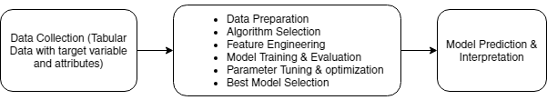

**LLM’s :**

Large language models use transformer models and are trained using massive datasets — hence, large. This enables them to recognize, translate, predict, or generate text or other content.

Like the human brain, large language models must be pre-trained and then fine-tuned so that they can solve text classification, question answering, document summarization, and text generation problems.

A **transformer model** is the most common architecture of a large language model. It consists of an encoder and a decoder. A transformer model processes data by tokenizing the input, then simultaneously conducting mathematical equations to discover relationships between tokens.

Transformer models work with self-attention mechanisms, which enables the model to learn more quickly than traditional models like long short-term memory models. Self-attention is what enables the transformer model to consider different parts of the sequence, or the entire context of a sentence, to generate predictions.

## 

## **Key components of large language models**

Large language models are composed of multiple neural network layers. Recurrent layers, feedforward layers, embedding layers, and attention layers work in tandem to process the input text and generate output content.

**The embedding layer** creates [embeddings](https://www.elastic.co/what-is/vector-embedding) from the input text. This part of the large language model captures the semantic and syntactic meaning of the input, so the model can understand context.

**The feedforward layer (FFN)** of a large language model is made of up multiple fully connected layers that transform the input embeddings. In so doing, these layers enable the model to glean higher-level abstractions — that is, to understand the user's intent with the text input.

**The recurrent layer** interprets the words in the input text in sequence. It captures the relationship between words in a sentence.

**The attention mechanism** enables a language model to focus on single parts of the input text that is relevant to the task at hand. This layer allows the model to generate the most accurate outputs.

**What is the difference between large language models and generative AI?**

[Generative AI](https://www.elastic.co/what-is/generative-ai) is an umbrella term that refers to artificial intelligence models that have the capability to generate content. Generative AI can generate text, code, images, video, and music. Examples of generative AI include Midjourney, DALL-E, and ChatGPT.

Large language models are a type of generative AI that are trained on text and produce textual content. ChatGPT is a popular example of generative text AI.

**Training:** Large language models are pre-trained using large textual datasets from sites like Wikipedia, GitHub, or others. These datasets consist of trillions of words, and their quality will affect the language model's performance. At this stage, the large language model engages in unsupervised learning, meaning it processes the datasets fed to it without specific instructions.

**Fine-tuning:** In order for a large language model to perform a specific task, such as translation, it must be fine-tuned to that particular activity. Fine-tuning optimizes the performance of specific tasks.

**Prompt-tuning** fulfills a similar function to fine-tuning, whereby it trains a model to perform a specific task through few-shot prompting, or zero-shot prompting. A prompt is an instruction given to an LLM.

**Limitations and challenges of large language models**

**Hallucinations:** A hallucination is when a LLM produces an output that is false, or that does not match the user's intent.

**Bias:** The data used to train language models will affect the outputs a given model produces. As such, if the data represents a single demographic, or lacks diversity, the outputs produced by the large language model will also lack diversity.

**Scaling:** It can be difficult and time- and resource-consuming to scale and maintain large language models.

**Deployment:** Deploying large language models requires deep learning, a transformer model, distributed software and hardware, and overall technical expertise.

**Vector embeddings** are a way to convert words and sentences and other data into numbers that capture their meaning and relationships. They represent different data types as points in a multidimensional space, where similar data points are clustered closer together.

**How are vector embeddings created?**

Vector embeddings are created through a machine learning process where a model is trained to convert any of the pieces of data listed above (as well as others) into numerical vectors.

Here is a quick overview of how it works:

* First, gather a large dataset that represents the type of data you want to create embeddings for, such as text or images.
* Next, you will preprocess the data. This requires cleaning and preparing the data by removing noise, normalizing text, resizing images, or various other tasks depending on the type of data you are working with.
* You will select a neural network model that is a good fit for your data goals and feed the preprocessed data into the model.
* The model learns patterns and relationships within the data by adjusting its internal parameters during training. For example, it learns to associate words that often appear together or to recognize visual features in images.
* As the model learns, it generates numerical vectors (or embeddings) that represent the meaning or characteristics of the data. Each data point, such as a word or an image, is represented by a unique vector.

**Types of vector embeddings:**

There are several different types of vector embeddings that are commonly used in various applications. Here are a few examples:

1. [**Word embeddings**](https://www.elastic.co/what-is/word-embedding)represent individual words as vectors. Techniques like Word2Vec, GloVe, and FastText learn word embeddings by capturing semantic relationships and contextual information from large text corpora.
2. **Sentence embeddings** represent entire sentences as vectors. Models like Universal Sentence Encoder (USE) and SkipThought generate embeddings that capture the overall meaning and context of the sentences.
3. **Document embeddings** represent documents (anything from newspaper articles and academic papers to books) as vectors. They capture the semantic information and context of the entire document. Techniques like Doc2Vec and Paragraph Vectors are designed to learn document embeddings.
4. **Image embeddings** represent images as vectors by capturing different visual features. Techniques like convolutional neural networks (CNNs) and pre-trained models like ResNet and VGG generate image embeddings for tasks like image classification, object detection, and image similarity.
5. **User embeddings** represent users in a system or platform as vectors. They capture user preferences, [behaviors](https://www.elastic.co/what-is/user-behavior-analytics), and characteristics.
6. **Product embeddings** represent products in ecommerce or recommendation systems as vectors. They capture a product’s attributes, features, and any other semantic information available.

**Building a Chatbot App**

To build a chatbot using a vector database, you can follow these steps:

* Choose a vector database such as Pinecone, Chroma, Weaviate, AWS Kendra, etc.
* Create a vector index for your chatbot.
* Train a language model using a large text corpus of your choice. For e.g, for a news chatbot, you can feed in news data.
* Integrate the vector database and the language model.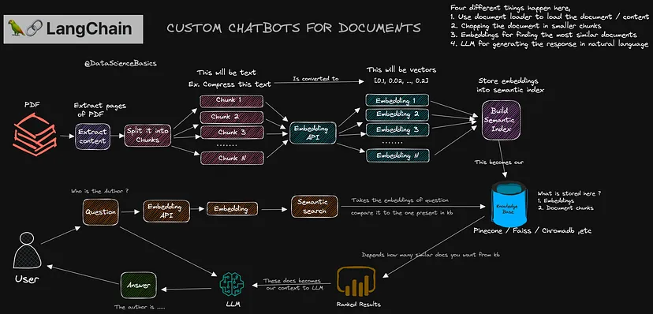

# **Building an Image Generator App**

# Let’s explore how to build an Image Generator app that uses both [Generative AI](https://www.analyticsvidhya.com/blog/2023/04/what-is-generative-ai/) and LLM libraries.

* Create a vector database to store your image vectors.
* Extract image vectors from your training data.
* Insert the image vectors into the vector database.
* Train a generative adversarial network (GAN). Read [here](https://www.analyticsvidhya.com/blog/2021/10/an-end-to-end-introduction-to-generative-adversarial-networksgans/) if you need an introduction to GAN.
* Integrate the vector database and the GAN.

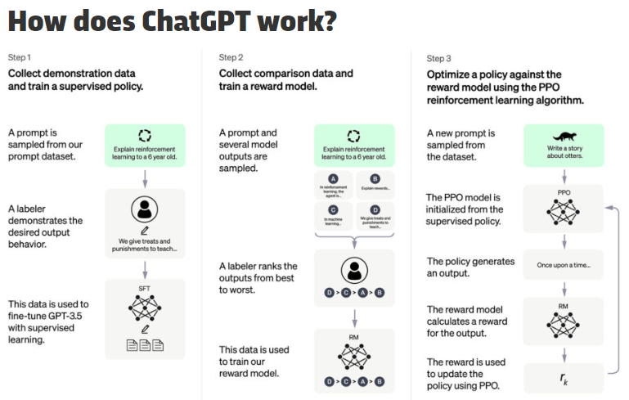

## **Building a Movie Recommendation App**

Let’s explore how to build a movie recommendation app from a movie corpus. You can use a similar idea to build a recommendation system for products or other entities.

* Create a vector database to store your movie vectors.
* Extract movie vectors from your movie metadata.
* Insert the movie vectors into the vector database.
* Recommend movies to users.